Safety Plan
SAMPLE ONLY

COVID Safety Plan

Please use the following form to document your plan for how your staff and patrons will be kept safe during the COVID-19 pandemic.

Premises name:

has a maximum

capacity of Number: patrons and agrees to the following conditions:

A strict limit of a minimum of 4sqm per person

A maximum of 20 patrons per venue (excluding staff)
Maintain records of patrons for the purposes of contact tracing where appropriate

Carefully manage waiting areas to ensure social distancing

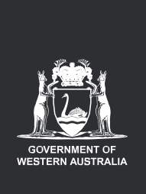






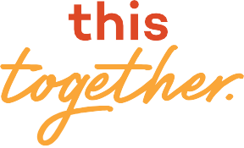


- Refer to the COVID Safety Guidelines for information on the expectations for COVID Safety Plans and to assist you in completing this plan. These are available at WA.gov.au
- Discuss and share relevant details of your plan with staff, contractors and suppliers so everyone is aware of what to do and what to expect.
- The COVID-19 pandemic is an evolving situation –
review your plan regularly and make changes as required.

- Print and display the COVID Safety Plan Certificate
available at the end of this form.

WA.gov.au

Premises details

SAMPLE ONLY
Premises name: Prepared by:
Type of premises: Position title:
Street address: Completion date:
Contact no: Revision date:
Email:

For the sections below, please complete the form and attach additional pages or information as required.
What will be done to implement physical distancing guidelines?
1. Physical and social distancing
*
Consider: physical distancing for staff and patrons; occupancy limits based on 4sqm requirements; management of waiting areas etc.

How will you ensure required hygiene standards are maintained?
2. Hygiene
- Reception area limited to 5 persons at a time to ensure 4sqm rule adherence (32sqm)
- Rope barriers and spacing marked out in front of counter to enforce 1.5m distancing from staff and patrons
- Internal layout, meeting rooms, waiting areas and desk spaces enable 4sqm rule
- 1.5m distancing marked on the floor in high traffic areas and workstations
- Staff stationed at entry and exit points to count and maintain maximum occupant levels

Consider: hygiene protocols and practices; supply of cleaning and sanitiser products etc.

- Hand sanitizer stations have been set-up at each entry and exit location
- Posters are present with directions on use
- Cleaning and inspection regularly occur for high touch amenities (e.g. lunch rooms, reception, toilets)and additional cleaning schedules provided
- Staff site specific induction training inclusive of the use and storage of cleaning and sanitizer products and facility practices
- Areas not to be used to be tagged out, covered, access restricted or marked not for use
- Cashless payments only is accepted at this time
- Cleaning products provided, stock levels maintained and readily accessible
- Cleaning procedures developed and register of cleaning completion is maintained
How will you ensure all your workers know how to keep themselves and others safe from exposure to COVID-19?
3. Staff training and education
SAMPLE ONLY
Consider: mandatory training; records of training; additional education; signage; guidance material etc.
- All staff are required to participate in a documented site specific induction including training and use of cleaning and sanitizer products
- Posters and signage placed within the facility covering venue requirements and restrictions
  - https://www.safeworkaustralia.gov.au/doc/signage-and-posters-covid-19
- Provision of guidance material for staff and others to keep safe from exposure
Regular staff meetings and minutes maintained where compliance requirements are discussed
Processes developed and workers trained in compliance requirements
Posters and notifications prominently on display within to communicate compliance requirements
Daily pre-start meeting with staff covering restrictions, policies, procedures, any changes and how to get assistance or raise an OSH issue
Occupational Safety and Health Act 1984
Occupational Safety and Health Regulations 1996
Good Hygiene Checklist
Cleaning Checklist
Yes
No
Comments:
I am aware that in addition to the legal obligations arising from the Emergency Management Act 2005 and the Directions made under that Act, I must continue to comply with relevant existing legislation and regulations, including WorkSafe legislation.
4. Compliance
How will you respond to an exposure or suspected exposure to COVID-19 within your premises?
5. Response planning
Consider: records of patrons; cleaning procedures; referrals to relevant authorities; regular review of procedures etc.
- Visitor sign in book regularly maintained at reception
- Notification procedure developed for a person suspected or confirmed case of COVID-19
  - Known case at, close contact displaying symptoms, or getting testing who accessed the facility call 1800 020 080
  - Person exhibiting symptoms such as difficulty breathing enact Facility Emergency Response Plan – Medical Attention Procedure
    - Call 000
    - Where possible isolate the individual and any others who have been in close contact and gather evidence (seek advice and assess the risks)
    - Debrief and review the facility risk assessment and controls for COVID-19
  - Persons feeling or appearing unwell are requested to leave or isolate away from group or class activities and avoid public transport – staff to call in sick to their manager and notify CEO
- Manager to notify cleaning services to direct cleaning contractors to clean and sanitize the workplace

Safety Plan
SAMPLE ONLY

Premises name
COVID Safety Plan Certificate

Welcome.
We can accommodate
Number:

patrons and agree to

maintain the WA Government’s safety measures

4sqm per person Staff training

Frequent cleaning and disinfection
Contact tracing







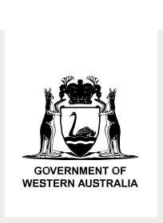

We’re doing our part to help keep you safe. Please respect the rules and our staff.

Date
Prepared by:

WA.gov.au

